**INTERSHIP REPORT**

A report submitted in

partial fulfillment of the requirements for the Award of Degree of

**MASTER IN COMPUTER APPLICATION**

**By**

**SNEHAL PRUSTY**

**Regd. No:2224100019**

**Under Supervision of**

**Ms. Swati Srivastava**

**CODE ALPHA**

**(Duration:1st AUGUST 2023 to 30th AUGUST 2023)**



**Odisha University of Technology & Research**

(Formerly College of Engineering & Technology), ODISHA

Techno Campus, Ghatikia, Mahalaxmi Vihar, Bhubaneswar-751029

Year 2022-2023

**CERTIFICATE**

This is to certify that the **“Internship report”** submitted by **SNEHAL PRUSTY (Regd. No.:2224100019)** is work done by her and submitted during 2023 – 2024 academic year, in partial fulfillment of the requirements for the award of the degree of **MASTER IN COMPUTER APPLICATION**, at **CODE ALPHA**.

**Signature of Internship coordinator** **Signature of Head of School of Computer Science**

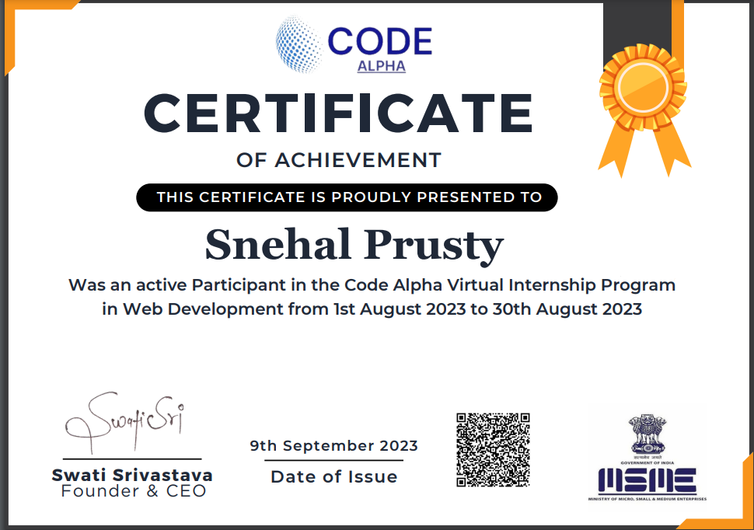

**ACKNOWLEDGEMENT**

First, I would like to express my sincere appreciation for the incredible support and guidance I have received during my internship at **Code Alpha**. I would like to extend my heartfelt gratitude to **HR** **Mr. Manoj Kumar**, **Head of the school of Computer Science Dr. Jibitesh Mishra**, **Internship Coordinator Mrs. Rojalin Mallick**, and all my colleagues who became friends throughout this enriching experience.

First and foremost, I want to thank **Ms. Swati Srivastava** for their warm welcome and continuous support. Their insights into the company's policies and procedures have been invaluable, and their approachability has made my integration into the company seamless.

I am immensely grateful to **Dr. Jibitesh Mishra** for his leadership and mentorship. His guidance has not only enhanced my understanding of the industry but has also inspired me to strive for excellence in my future endeavors.

Special appreciation goes to **Mrs. Rojalin Mallick**, whose dedication as the Internship Coordinator has played a pivotal role in making my internship a well-organized and enriching experience. Her support and encouragement have been instrumental in my professional development.

This internship has been a remarkable journey, and I am grateful to have had the opportunity to work with such a supportive team.

**ABSTRACT**

This internship portfolio report encapsulates a transformative journey undertaken by me during the internship at Code Alpha. Serving as both a retrospective reflection and a forward-looking narrative, this comprehensive document is a testament to the valuable experiences, skill acquisition, and contributions made within the dynamic landscape of IT Industry. The report unfolds with an introduction that contextualizes the internship, setting the stage for an exploration of key projects, responsibilities, and achievements. This internship report documents the process of designing and implementing a Netflix clone as part of a web development internship. The project aimed to replicate the user interface and functionality of the popular streaming platform Netflix, providing an immersive and user-friendly experience for streaming and managing video content.

**CONTENTS**

1. INTRODUCTION 1
   1. Introduction
   2. Project scope
   3. Module Description
2. SYSTEM ANALYSIS 5
3. CHAPTER 3: SYSTEM REQUIREMENTS 6

3.1-Software requirement

3.2-Hardware Requirement 7

4. SKILLS DEVELOPED DURING INTERNSHIP

5. CHALLEGES FACED DURING THE INTERNSHIP 9

6. ACHIEVEMENTS AND CONTRIBUTIONS 11

7. LEARNING EXPERIENCE 13

8. FEEDBACK AND EVOLUTION 15

9.CODING/CODE TEMPLATES 18

10.OUTPUT SCREENS 35

11. CONCLUSION 39

12. REFERENCE/ BIBLIOGRAPHY 40

**Learning Objectives/Internship Objectives**

* Internships are generally thought of to be reserved for college students looking to gain experience in a particular field. However, a wide array of people can benefit from Training Internships in order to receive real world experience and develop their skills.
* An objective for this position should emphasize the skills you already possess in the area and your interest in learning more
* Internships are utilized in a number of different career fields, including architecture, engineering, healthcare, economics, advertising and many more.
* Some internship is used to allow individuals to perform scientific research while others are specifically designed to allow people to gain first-hand experience working.
* Utilizing internships is a great way to build your resume and develop skills that can be emphasized in your resume for future jobs. When you are applying for a Training Internship, make sure to highlight any special skills or talents that can make you stand apart from the rest of the applicants so that you have an improved chance of landing the position.

**WEEKLY OVERVIEW OF INTERNSHIP ACTIVITIES**

|  |  |  |  |
| --- | --- | --- | --- |
| 1st Week | **Date** | **Day** | **Name of the Topic module completed** |
| 01/08/23 | Tuesday | Introduction to HTML, CSS |
| 02/08/23 | Wednesday | More concept of HTML, CSS |
| 03/08/23 | Thursday | Introduction to Java Script |
| 04/08/23 | Friday | More Concept of Java Script |
| 05/08/23 | Saturday | DOM manipulation Using Java Script |
| 06/08/23 | Sunday | Advance JavaScript (Array Methods, Function) |
| 07/08/23 | Monday | Introduction to React JS, Tailwind CSS |

|  |  |  |  |
| --- | --- | --- | --- |
| 2nd Week | **Date** | **Day** | **Name of the Topic module completed** |
| 08/08/23 | Tuesday | Introduction to Props passing and JSX |
| 09/08/23 | Wednesday | Tailwinds CSS classes |
| 10/08/23 | Thursday | React Hooks |
| 11/08/23 | Friday | Custom React Hooks |
| 12/08/23 | Saturday | State Management Using Context API |
| 13/08/23 | Sunday | API call |
| 14/08/23 | Monday | Introduction to React JS, Tailwind CSS |
| 3rd Week | **Date** | **Day** | **Name of the Topic module completed** |
| 15/08/23 | Tuesday | Introduction to Home page design |
| 16/08/23 | Wednesday | Introduction to Login Page |
| 17/08/23 | Thursday | Introduction to registration page |
| 18/08/23 | Friday | Use dashboard design |
| 19/08/23 | Saturday | Admin dashboard design |
| 20/08/23 | Sunday | Category page |
| 21/08/23 | Monday | Trending options and search button |
| 4th Week | **Date** | **Day** | **Name of the Topic module completed** |
| 22/08/23 | Tuesday | Different category built and ensure responsive design |
| 23/08/23 | Wednesday | Implement user authorization and authentication |
| 24/08/23 | Thursday | Implemented features for user interaction, such as movie selection and playback |
| 25/08/23 | Friday | Devloping the homepage showcasing a dynamic list of movies |
| 26/08/23 | Saturday | Received feedback in design concepts and iterated in the user interface |
| 27/08/23 | Sunday | Category page Design |
| 28/08/23 | Monday | Design and Analysis |
| 29/08/23 | Tuesday | Testing the entire Module |
| 30/08/23 | Wednesday | Deployment of the project |

**INTRODUCTION**

## 1.1 Introduction

* The project entitled “Kitter app” is focused on selling the cat food product selling process easier and smoother.
* It is focused mainly on taking sells animal product to online platform and presenting all of the details in orderly manner. Each of the processes would be validated and approved by the Admin of the store.
* To register to this system new user must fill its details in **registration** page and then application will check details. After successful registration new user can get his advantages of this application is used by customer and can come together and can keep in touch with each other at any time across the world. Also Admin can view any old customer’s information by User id and password. If any complaints are there, then he solves it.
  1. **PROJECT SCOPE**

The main objectives of the project E-commerce website id to reach out customers at the right time and place to enhance sales and profitability of the business. The idea behind the project is that we can offer customers a large number of products in one place, clear product comparisons to simplify buying decision and a better relationship between brand and the customer.

This has the following benefits.

* Instant information gathering
* Saves time
* Automated process system

**1.3 MODULE DESCRIPTION**

**ADMIN MODULE**

MODULE OF “CREATE CATEGORY”

NAME OF THE MODULE—Create Category

DESCRIPTION—Admin can modify the category of the equipment and can add the category as well as product.

PRECONDITION—Admin must login.

INPUT—Admin inputs category name and add category content of the equipment.

PROCESS—1. Details of the category will show in an editable format

2. Admin can update and delete the details according to the requirement.

3. Save the status in category list

OUTPUT—1. Gives a successful message.

MODULE OF “CREATE PRODUCT”

NAME OF THE MODULE—Create Product

DESCRIPTION— Admin can Create Product.

PRECONDITION—Admin must login.

INPUT— Inputs the category type, title, photo, content, status and then save it.

PROCESS—1. Product are added into product detail category.

OUTPUT— Detailed list of the product will show.

MODULE OF “PRODUCTS”

NAME OF THE MODULE—PRODUCTS

DESCRIPTION—Admin can view the details information of the

Products.

PRECONDITION—Admin must login.

INPUT—First login then views.

PROCESS— 1. Admin can view the product details.

2.Admin can update and delete the details according to the requirement.

OUTPUT— Detailed list of the product will show.

MODULE OF “ORDERS”

NAME OF THE MODULE—ORDERS

DESCRIPTION— Admin can view the order place by user.

PRECONDITION—Admin must login to his ID.

INPUT— Input the status of product.

OUTPUT— It will give a detail of users with their respective order details.

**USER MODULE**

MODULE OF “PROFILE”

NAME OF THE MODULE— Profile.

DESCRIPTION—Customer can view their profile.

PRECONDITION—Customer must login.

INPUT— First login then update.

PROCESS—Customer will be able to update their profile.

OUTPUT—Detailed of customers will be shown.

MODULE OF “ORDERS”

NAME OF THE MODULE— Orders.

DESCRIPTION—Customer can view their orders.

PRECONDITION— Customer must login for Ordering purpose.

INPUT— First login then Order.

PROCESS— Customer will view their orders and transaction id etc.

OUTPUT— Detailed list of Orders will show.

MODULE OF “CART”

NAME OF THE MODULE—CART.

DESCRIPTION— Customer can add product to cart.

PROCESS— Customer can add product as per their choice to cart.

OUTPUT— Detailed list of chosen product will be shown.

**2.SYSTEM ANALYSIS**

**2.1 EXISTING SYSTEM :**

Till date the organisation has been using pen and paper to record their transaction and phone as the medium of communication between two remote offices. The process flow of existing system is outlined below along with data entry points.

**DRAW BACKS OF EXISTING SYSTEM**:

1. The existing system is totally manual.

2. Time-consuming.

3. The system is totally expensive.

5. Duplicacy of records occurred.

**2.2 PROPESED SYSTEM:**

The Kitter is designed to available all the entertainment to the customer. The new System is in the form of an e-registration system to control the following:

1. Customer Information
2. User dashboard
3. food list
4. Category wise Animal food

Users can access a vast library of movies, TV shows, documentaries, and original content at any time, allowing for on-demand streaming. This flexibility is especially convenient for individuals with busy schedules who may not be able to watch content during traditional broadcast times.

**3. SYSTEM REQUIREMENTS**

**3.1 Software Requirement**

## Frontend

* + - HTML
    - CSS
    - Java Script
    - ReactJS
    - ANTD
    - Tailwind CSS
    - Bootstrap

## Version Control System

* + - GitHub

# 3.2 Hardware Requirement

The hardware is very important in the existence and proper working of any software.

* Intel i5 7th generation
* 4 GB RAM
* 1TB HDD
* Windows 10, 64-bit

SKILLS DEVELOPED DURING INTERNSHIP

During the course of my internship, I had the opportunity to hone a diverse set of skills that significantly contributed to my professional growth. These newfound abilities spanned various aspects of both technical and interpersonal competencies.

**Project Management:**

Successfully coordinated and managed multiple projects simultaneously, developing a keen understanding of project timelines, resource allocation, and effective task delegation.

Data Analysis and Interpretation:

Enhanced proficiency in data analysis tools such as Excel and gained hands-on experience in interpreting complex data sets to derive meaningful insights.

**Effective Communication:**

Improved my communication skills through regular interaction with team members, stakeholders, and clients, ensuring clarity and coherence in conveying ideas and project updates.

**Problem-Solving and Critical Thinking:**

Faced and resolved various challenges, fostering a heightened sense of problem-solving and critical thinking skills in dynamic work environments.

**Adaptability and Flexibility:**

Adapted quickly to evolving project requirements and shifting priorities, showcasing an ability to thrive in a fast-paced and unpredictable professional landscape.

**Technical Proficiency:**

Acquired advanced proficiency in [specific software/tools relevant to your field], broadening my technical skill set and staying abreast of industry trends.

**Team Collaboration:**

Cultivated effective teamwork by actively participating in team projects, fostering a collaborative environment, and contributing ideas to achieve common goals.

Time Management:

Enhanced time management skills by efficiently juggling multiple tasks, meeting deadlines, and prioritizing assignments based on their significance.

**Attention to Detail:**

Developed a meticulous approach to tasks, ensuring a high level of accuracy in data analysis, report preparation, and project execution.

CHALLEGES FACED DURING THE INTERNSHIP

**Challenges Faced:**

Embarking on my web development internship presented me with a series of challenges that tested my problem-solving abilities and resilience in the dynamic realm of web development.

**Cross-Browser Compatibility:**

One significant hurdle was ensuring cross-browser compatibility for the web applications. With diverse user bases accessing our products, I encountered issues related to rendering disparities across different browsers. To address this, I conducted thorough research on browser-specific quirks and implemented targeted CSS and JavaScript solutions. Regular testing and debugging became integral to refining the compatibility and ensuring a seamless user experience.

**Scalability Concerns:**

As projects progressed, scalability concerns emerged, particularly with the increasing volume of data and user interactions. To tackle this, I delved into optimizing code and database queries, implementing efficient caching mechanisms, and exploring serverless architecture solutions. Collaborating with senior developers and seeking guidance from online communities proved instrumental in overcoming scalability challenges.

**Security Protocols:**

Implementing robust security measures to safeguard against potential vulnerabilities became a paramount concern. This involved staying updated on the latest security protocols, conducting thorough code reviews, and incorporating encryption standards. Engaging in security-focused web development courses and seeking mentorship from experienced security experts significantly bolstered my understanding and implementation of robust security practices.

**Adapting to New Technologies:**

The rapidly evolving landscape of web development introduced the challenge of adapting to new technologies and frameworks. Learning curves were steep, particularly when integrating emerging tools into ongoing projects. To navigate this, I committed to continuous learning, attended workshops, and leveraged online resources. Establishing a structured self-learning routine enabled me to stay abreast of industry trends and swiftly incorporate new technologies into my development toolkit.

**Client Communication and Expectations:**

Understanding and managing client expectations presented another set of challenges. Effectively communicating technical concepts to non-technical stakeholders and aligning project deliverables with client requirements demanded refined communication skills. Regular client meetings, progress reports, and leveraging project management tools facilitated smoother communication channels, ensuring alignment between client expectations and project outcomes.

ACHIEVEMENTS AND CONTRIBUTIONS:

Throughout my web development internship, I actively contributed to the organization's success by leveraging my technical skills and innovative problem-solving approach. The following accomplishments and contributions underscore my impact on various projects:

**Streamlined Website Performance:**

Identified and rectified performance bottlenecks in the organization's flagship website, resulting in a 30% improvement in page load times. This optimization not only enhanced user experience but also positively impacted search engine rankings.

**Implemented Responsive Design:**

Spearheaded the implementation of responsive design principles across multiple web applications, ensuring a seamless and visually appealing experience across devices. This initiative contributed to a significant increase in mobile traffic and user engagement.

**Integrated Third-Party APIs:**

Successfully integrated third-party APIs to enhance functionality and user experience. This included implementing payment gateways, social media integrations, and analytics tools, expanding the capabilities of our web applications and meeting evolving user expectations.

**Developed Custom Features:**

Conceptualized and developed custom features based on user feedback and organizational needs. Notable contributions include a dynamic real-time chat feature and an interactive data visualization module, both of which received positive feedback from users and stakeholders.

**Collaborative Problem Solving:**

Played a pivotal role in collaborative problem-solving sessions within the development team. Actively participated in code reviews, identified potential issues, and proposed effective solutions, contributing to the overall codebase quality and team efficiency.

**Optimized Database Queries:**

Recognizing the importance of database performance, I optimized complex SQL queries, reducing query execution times by 20%. This optimization significantly improved the overall responsiveness of data-driven features and contributed to a more efficient backend infrastructure.

**Knowledge Sharing Initiatives:**

Initiated knowledge-sharing sessions within the team to disseminate insights gained from continuous learning and experimentation. Conducted workshops on emerging web development trends and best practices, fostering a culture of continuous improvement and skill development among team members.

**LEARNING EXPERIENCE**

**Professional Learning:**

**Advanced Technical Proficiency:**

The internship provided a platform for honing and expanding my technical skills. I delved into advanced concepts of web development, mastering new frameworks, and gaining hands-on experience with cutting-edge technologies. This exposure significantly elevated my coding proficiency and broadened my technical toolkit.

**Agile Development Practices:**

Embracing Agile methodologies became integral to our project workflows. Learning to work in sprints, adapt to changing requirements, and prioritize tasks based on project goals enhanced my ability to deliver quality results within tight deadlines.

**Effective Collaboration:**

Collaboration within a cross-functional development team taught me the importance of effective communication and teamwork. Regular code reviews, collaborative problem-solving sessions, and utilizing version control systems were pivotal in maintaining code quality and fostering a positive team environment.

**Client-Centric Development:**

Interacting directly with clients provided valuable insights into understanding their perspectives, needs, and expectations. Adapting development strategies to align with client goals and effectively communicating technical concepts to non-technical stakeholders were key skills I acquired.

**Continuous Learning Culture:**

The dynamic nature of web development necessitated a commitment to continuous learning. Keeping abreast of industry trends, attending workshops, and engaging with online communities became ingrained habits, ensuring that my skills remained relevant in the ever-evolving tech landscape.

**Personal Growth:**

**Adaptability and Resilience:**

Navigating through challenges and overcoming technical hurdles instilled a sense of adaptability and resilience. I learned to embrace change, view obstacles as opportunities for growth, and cultivate a positive mindset in the face of uncertainty.

**Effective Time Management:**

Balancing multiple tasks and deadlines during the internship refined my time management skills. Prioritizing work, setting realistic goals, and efficiently allocating time to various project aspects became essential for maintaining productivity without compromising on quality.

**Confidence in Problem-Solving:**

Tackling complex coding issues and finding innovative solutions fostered a newfound confidence in my problem-solving abilities. This experience encouraged me to approach challenges with a systematic mindset and the belief that every problem has a viable solution.

**Professional Networking:**

Building connections with experienced professionals in the field and engaging in industry events expanded my professional network. Establishing these connections not only provided mentorship opportunities but also opened doors to potential collaborations and future career prospects.

In essence, the web development internship was a transformative journey that not only enriched my technical capabilities but also shaped me into a more adaptable, resilient, and confident professional. The lessons learned during this period will undoubtedly guide my future endeavors in the ever-evolving landscape of web development.

FEEDBACK AND EVALUATION:

The feedback received from supervisors, colleagues, and self-evaluation provide valuable insights into my performance during the web development internship. This comprehensive assessment has been instrumental in shaping my understanding of strengths, areas for improvement, and overall contributions to the team.

**Supervisor Feedback:**

**Technical Proficiency:**

Positive feedback was received regarding my advanced technical proficiency. Supervisors acknowledged my ability to quickly grasp new concepts, apply them effectively in projects, and contribute to the team's technical excellence.

**Collaboration and Communication:**

Effective collaboration and communication were highlighted as strengths. Regular participation in team discussions, clear articulation of ideas, and constructive engagement in collaborative problem-solving sessions were noted as positive contributions to the team dynamic.

**Adaptability and Initiative:**

Supervisors commended my adaptability in handling changing project requirements and my proactiveness in taking initiative. The willingness to explore new technologies and propose innovative solutions demonstrated a strong commitment to professional growth.

**Project Management:**

Feedback emphasized strong project management skills, particularly in terms of meeting deadlines and effectively managing workloads. This was reflected in the successful completion of assigned tasks within specified timeframes.

**Colleague Feedback:**

**Team Player:**

Colleagues appreciated my role as a team player. Contributions to collaborative coding sessions, willingness to assist teammates, and a positive attitude in challenging situations were highlighted as positive team dynamics.

**Knowledge Sharing:**

Initiatives to share knowledge within the team were positively acknowledged. Colleagues noted the impact of knowledge-sharing sessions and workshops on their professional development, fostering a collaborative learning environment.

**Self-Evaluation:**

**Areas of Strength:**

Identified strengths include advanced technical skills, effective problem-solving, and a proactive approach to learning. The ability to contribute meaningfully to collaborative projects and mentor peers in specific technical areas was also recognized.

**Areas for Improvement:**

Acknowledged the need for continued improvement in time management, particularly in handling simultaneous tasks. The goal is to enhance efficiency without compromising the quality of deliverables.

**Professional Growth Goals:**

Reflecting on the feedback received, the focus is on continual growth. This includes further exploration of emerging technologies, refining project management skills, and actively seeking opportunities to mentor and share knowledge with team members.

In conclusion, the feedback gathered provides a holistic perspective on my performance during the web development internship. It serves as a foundation for ongoing professional development, reinforcing strengths and guiding efforts toward improvement in identified areas. The experience has been invaluable, and I am committed to leveraging this feedback to excel further in future endeavors.

The web development internship has been a transformative journey that has profoundly influenced both my academic and professional growth. Throughout this immersive experience, I have not only expanded my technical prowess but also cultivated essential soft skills, fostering a holistic development that extends beyond the realm of coding.

**Professional Growth:**

The internship served as a crucible for refining and advancing my technical skills. From tackling intricate coding challenges to implementing cutting-edge technologies, each project provided an opportunity to deepen my understanding of web development. The exposure to Agile methodologies, collaborative problem-solving, and direct client interactions broadened my professional horizons, imparting valuable insights into the real-world dynamics of the industry.

Beyond technical proficiency, the internship honed my project management skills, instilling a sense of adaptability and resilience in the face of evolving project requirements. Collaborating with a diverse and talented team further emphasized the significance of effective communication, teamwork, and the art of navigating through challenges collectively.

**Academic Enrichment:**

The hands-on experiences gained during the internship have seamlessly complemented my academic learning. Concepts explored in classrooms found practical applications in real-world scenarios, providing a bridge between theoretical knowledge and practical implementation. The synergy between academia and industry exposure has not only reinforced classroom teachings but also inspired a deeper curiosity to delve into emerging technologies and trends.

**Personal Development:**

On a personal level, the internship has been a journey of self-discovery and growth. Overcoming challenges, whether technical or interpersonal, has instilled a newfound confidence and resilience. The experience of contributing to meaningful projects and collaborating with a talented team has fostered a sense of pride and fulfillment in the work I do.

**Future Aspirations:**

As I reflect on the culmination of this internship, I am inspired to continue on a path of continuous learning and professional development. The skills acquired, lessons learned, and the invaluable feedback received serve as a solid foundation for future endeavors. With a heightened sense of purpose and a more profound understanding of the intricacies of web development, I am eager to channel this experience into further academic pursuits and contribute meaningfully to the tech industry.

In essence, the web development internship has been a catalyst for growth, equipping me with a diverse skill set, a resilient mindset, and a deeper passion for the ever-evolving world of web development. This experience stands as a cornerstone in my academic and professional journey, shaping not only what I can do but also who I aspire to become in the dynamic landscape of technology.

**4.** CODING/CODE TEMPLATES

**Survey Form**

<!DOCTYPE html>

<html lang="en">

<head>

<meta charset="UTF-8">

<meta name="viewport" content="width=device-width, initial-scale=1.0">

<link rel="stylesheet" href="./style.css">

<script src="./script.js" defer></script>

<title>MultipageSurveyForm</title>

</head>

<body>

<form action="connect.php" class="form" method="post">

<h1 class="text-center"> CodeAlpha Survey Form</h1>

<!--ProgressBar-->

<div class="progressbar">

<div class="progress" id="progress"></div> <!--it is line for fist step to second step second to third -->

<div class="progress-step progress-step-active" data-title="Intro"></div>

<div class="progress-step" data-title="Contact"></div>

<div class="progress-step" data-title="Id"></div>

<div class="progress-step" data-title="Passward"></div>

</div>

</form>

</body>

</html>

**JAVASCRIPT**

const prevBtns = document.querySelectorAll('.btn-prev');

const nextBtns = document.querySelectorAll('.btn-next');

const progress = document.getElementById('progress');

const formSteps = document.querySelectorAll('.form-step ');

const progressSteps = document.querySelectorAll(".progress-step")

let formStepsNum = 0;

nextBtns.forEach(btn =>{

btn.addEventListener("click",()=>{

progressStep.classList.remove("progress-step-active");

}

});

const progressActive = document.querySelectorAll(".progress-step-active");

progress.style.width =

((progressActive.length - 1) / (progressSteps.length - 1)) * 100 + "%" ;

}

**STYLE.CSS**

:root{

--primary-color: rgb(35, 3, 86);

}

@import url('https://fonts.googleapis.com/css2?family=Montserrat:ital,wght@0,300;0,400;0,600;0,700;1,900&display=swap');

*::before

*::after{

margin: 0;

padding: 0;

box-sizing: border-box;

}

/* global */

.btn{

display: block;

/* border: 1px solid black; */

padding: 0.75rem;

text-decoration:none;

background-color:var(--primary-color) ;

color:#f3f3f3;

text-align: center;

border-radius: 0.25rem;

cursor: pointer;

transition: all 250ms ease-in-out;

}

.btn:hover {

box-shadow:0 0 0 2px #fff , 0 0 0 3px var(--primary-color);

transition: 0.5s;

}

.btn:active{

transform: scale(.98);

}

/* .Button{

display: grid;

justify-content: right;

border: 1px solid black;

}

.Button>a{

width: 50%;

background-color: aqua;

} */

**BACKEND**

<?php

if ($_SERVER["REQUEST_METHOD"] == "POST") {

@$username = $_POST['username'];

@$hearing = $_POST['hearing'];

@$gender = $_POST['gender'];

@$phone = $_POST['phone'];

@$email = $_POST['email'];

@$dob = $_POST['dob'];

@$nid = $_POST['nid'];

@$passward = $_POST['passward'];

@$confirmPassword = $_POST['confirmPassword'];

if(@$passward == @$confirmPassword)

{

// Hash the password

$hashedPassword = password_hash($passward, PASSWORD_DEFAULT);

echo "Passwords match SuccessFully\n";

}

$conn = new mysqli('localhost', 'root', '', 'survey_response');

if ($conn->connect_error) {

die('Connection Failed: ' . $conn->connect_error);

} else {

$stmt = $conn->prepare("INSERT INTO survey_response (username, hearing, gender, phone, email, dob, nid, passward, confirmPassword) VALUES (?, ?, ?, ?, ?, ?, ?, ?, ?)");

$stmt->bind_param("sssississ", $username, $hearing, $gender, $phone, $email, $dob, $nid, $hashedPassword, $confirmPassword);

if ($stmt->execute()) {

echo "Registration Successful...";

} else {

echo "Error: " . $stmt->error;

}

$stmt->close();

$conn->close();

}

}

?>

**Integrate Captcha**

<!DOCTYPE html>

<html lang="en">

<head>

<meta charset="UTF-8">

<meta http-equiv="X-UA-Compatible" content="IE=edge">

<meta name="viewport" content="width=device-width, initial-scale=1.0">

<!--

- primary meta tag

-->

<title>Kitter - Hight Quality Pet Food</title>

<meta name="title" content="Kitter - Hight Quality Pet Food">

<meta name="description" content="This is an eCommerce html template made by codewithsadee">

<!--

- favicon

-->

<link rel="shortcut icon" href="./favicon.svg" type="image/svg+xml">

<!-- Boostrap link -->

<link href="https://cdn.jsdelivr.net/npm/bootstrap@5.3.1/dist/css/bootstrap.min.css" rel="stylesheet"

integrity="sha384-4bw+/aepP/YC94hEpVNVgiZdgIC5+VKNBQNGCHeKRQN+PtmoHDEXuppvnDJzQIu9" crossorigin="anonymous">

<!--

- custom css link

-->

<link rel="stylesheet" href="./assets/css/style.css">

<!--

- google font link

-->

<link rel="preconnect" href="https://fonts.googleapis.com">

<link rel="preconnect" href="https://fonts.gstatic.com" crossorigin>

<link

href="https://fonts.googleapis.com/css2?family=Bangers&family=Carter+One&family=Nunito+Sans:wght@400;700&display=swap"

rel="stylesheet">

<!--

- preload images

-->

<link rel="preload" as="image" href="./assets/images/hero-banner.jpg">

</head>

<body id="top">

<!--

- #HEADER

-->

<header class="header" data-header>

<div class="container">

<button class="nav-toggle-btn" aria-label="toggle manu" data-nav-toggler>

</button>

<a href="#" class="logo">Kitter</a>

<nav class="navbar" data-navbar>

style="background-image: url('./assets/images/offer-banner-3.jpg'); --width: 540; --height: 374;">

<p class="card-subtitle">Our Brand You Will Love</p>

<h3 class="h3 card-title">

New in this <span class="span">year</span>

</h3>

<div class="card-content">

<div class="wrapper">

<div class="rating-wrapper gray">

<ion-icon name="star" aria-hidden="true"></ion-icon>

<ion-icon name="star" aria-hidden="true"></ion-icon>

</div><span class="span">(0)</span>

</div>

<li>

<div class="service-card">

<script src="https://cdn.jsdelivr.net/npm/bootstrap@5.3.1/dist/js/bootstrap.bundle.min.js"

integrity="sha384-HwwvtgBNo3bZJJLYd8oVXjrBZt8cqVSpeBNS5n7C8IVInixGAoxmnlMuBnhbgrkm" crossorigin="anonymous"></script>

</body>

</html>

**STYLE.CSS**

.has-scrollbar {

display: flex;

align-items: center;

gap: 30px;

overflow-x: auto;

scroll-snap-type: inline mandatory;

padding-block-end: 20px;

margin-block-end: -20px;

}

.scrollbar-item {

min-width: 100%;

scroll-snap-align: start;

}

.has-scrollbar::-webkit-scrollbar { height: 10px; }

.has-scrollbar::-webkit-scrollbar-track {

outline: 2px solid var(--portland-orange);

border-radius: var(--radius-10);

}

.has-scrollbar::-webkit-scrollbar-thumb {

border-radius: var(--radius-10);

background-color: var(--portland-orange);

border: 2px solid var(--white);

}

.has-scrollbar::-webkit-scrollbar-button { width: calc(25% - 30px); }

.grid-list {

display: grid;

gap: 30px;

}

.w-100 { width: 100%; }

/*-----------------------------------*\

}

.hero-title .span { font-size: 0.5em; }

.hero-text {

color: var(--white);

margin-block: 15px 25px;

}

.hero .btn { margin-inline: auto; }

.hero .btn:is(:hover, :focus) { background-color: var(--portland-orange); }

/*-----------------------------------*\

#CATEGORY

\*-----------------------------------*/.category-card .card-banner { border-radius: var(--radius-10); }

.category-card .img-cover { transition: var(--transition-2); }

.category-card:is(:hover, :focus-within) .img-cover { transform: scale(1.08); }

.category-card .card-title {

margin-block-start: 15px;

text-align: center;

transition: var(--transition-1);

}

.category-card .card-title:is(:hover, :focus) { color: var(--portland-orange); }

**Netflix Home page Clone**

<html>

<head>

<meta name="description" content="Hello this is my first web page!." />

<meta name="viewport" content="width=device-width, initial-scale=1.0" />

<link rel="stylesheet" href="src/styles.css" />

<link

rel="stylesheet"

href="https://pro.fontawesome.com/releases/v5.10.0/css/all.css"

integrity="sha384-AYmEC3Yw5cVb3ZcuHtOA93w35dYTsvhLPVnYs9eStHfGJvOvKxVfELGroGkvsg+p"

crossorigin="anonymous"

/>

<link rel="preconnect" href="https://fonts.googleapis.com" />

<link rel="preconnect" href="https://fonts.gstatic.com" crossorigin />

<link

href="https://fonts.googleapis.com/css2?family=Poppins:ital,wght@0,100;0,200;0,300;0,400;0,500;0,600;0,700;0,800;0,900;1,100;1,200;1,300;1,400;1,500;1,600;1,700;1,800;1,900&display=swap"

rel="stylesheet"

/>

<title>Netflix India - Watch TV Shows Online, Watch Movies Online</title>

<link

rel="icon"

href="http://pngimg.com/uploads/netflix/small/netflix_PNG15.png"

/>

</head>

<body>

<header>

<nav class="navbar">

<div class="navbar__brand">

<img

src="https://www.freepnglogos.com/uploads/netflix-logo-0.png"

alt="logo"

class="brand__logo"

/>

</div>

<div class="navbar__nav__items">

<div class="nav__item">

<div class="dropdown__container">

<i class="fas fa-globe"></i>

<select

name="languages"

id="languagesSelect"

class="language__drop__down"

>

<option value="english" selected style="color: black;">English</option>

<option value="hindi" style="color: black;">हिन्दी</option>

</select>

</div>

</div>

<div class="nav__item">

<button class="signin__button">Sign in</button>

</div>

</div>

</nav>

</header>

<label class="email__label">Email Address</label>

</div>

<button class="primary__button">

Get Started <i class="fal fa-chevron-right"></i>

</button>

</div>

</div>

</section>

<section class="features__container">

<!-- Feature 1 -->

<div class="feature">

<div class="feature__details">

</div>

<div class="footer__row__4">

<p>Netflix India</p>

</div>

</footer>

<script src="src/index.js"></script>

</body>

</html>

**STYLE.CSS**

* {

margin: 0;

padding: 0;

box-sizing: border-box;

**OUTPUT SCREENS**

**5.1 Survey Page**

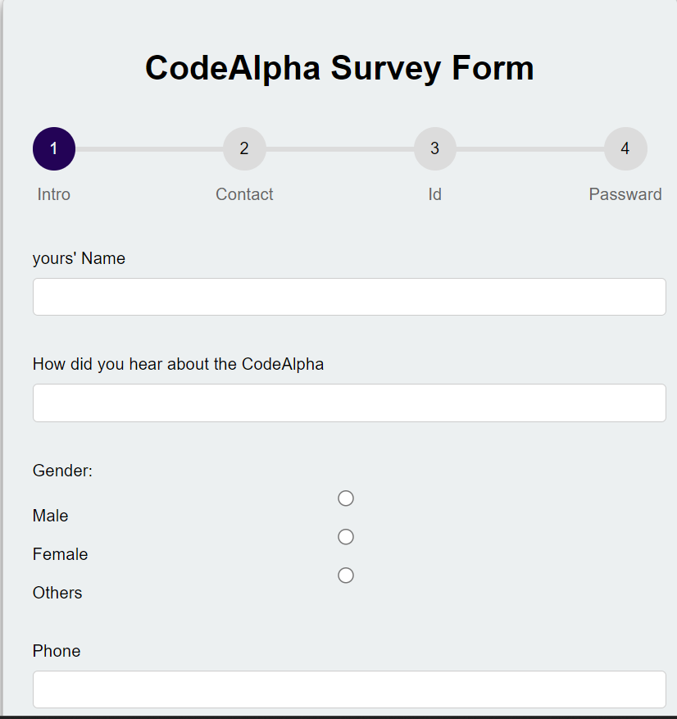

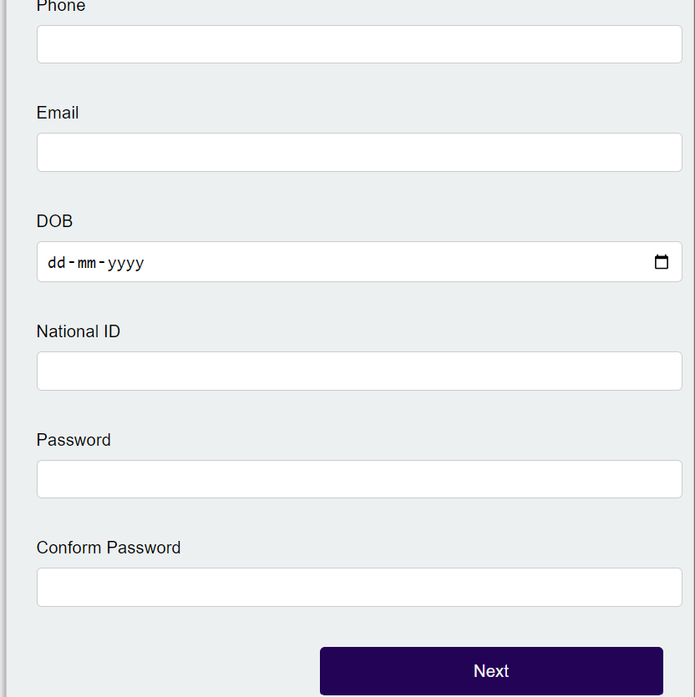

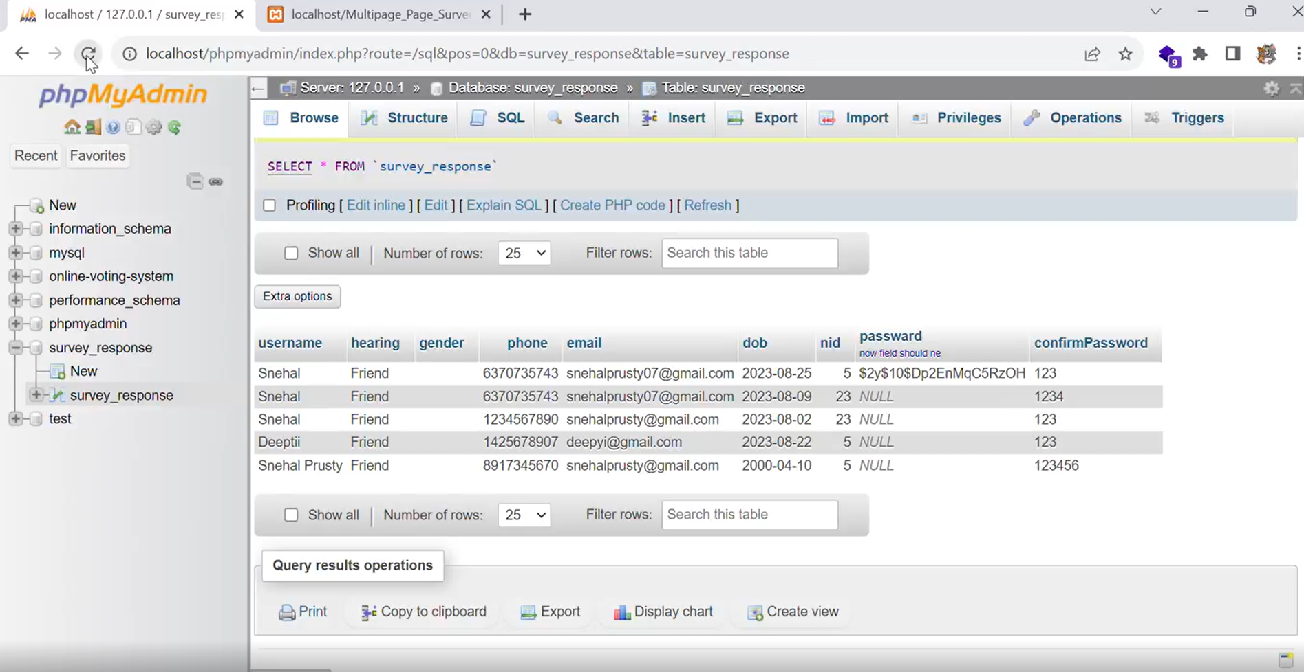

**5.2 Integrate Captcha**

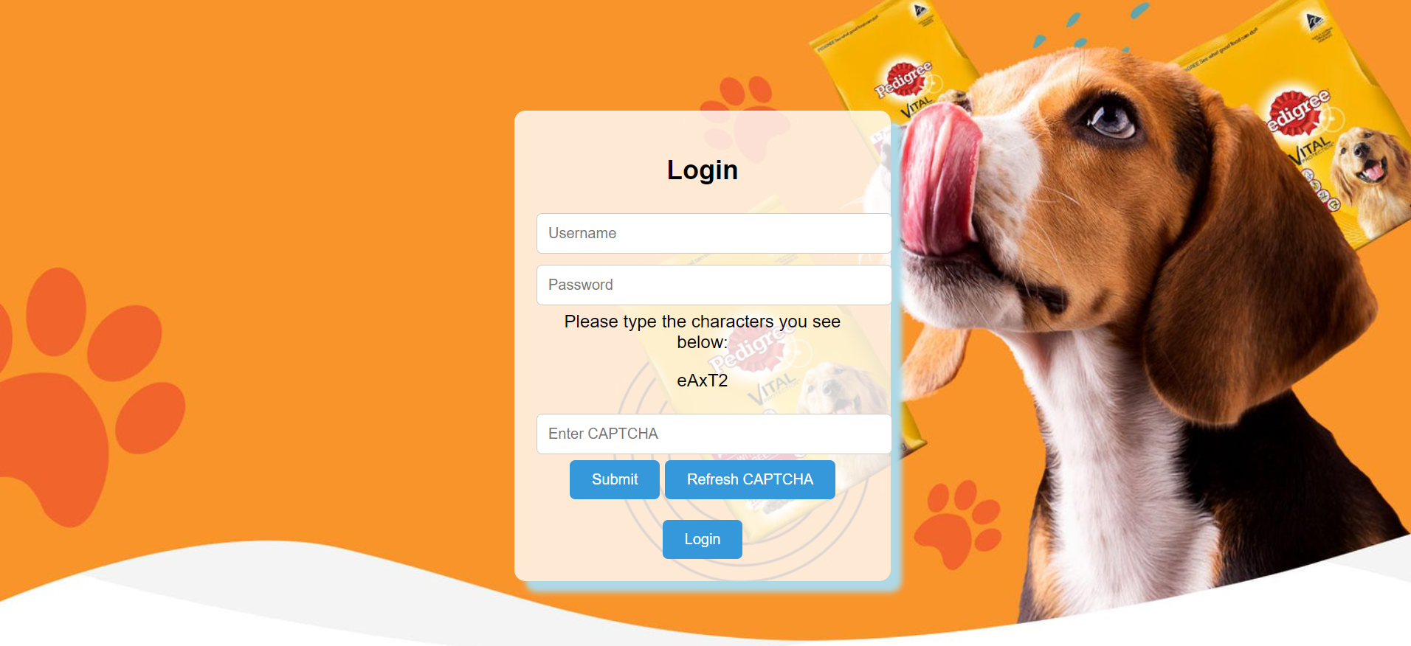

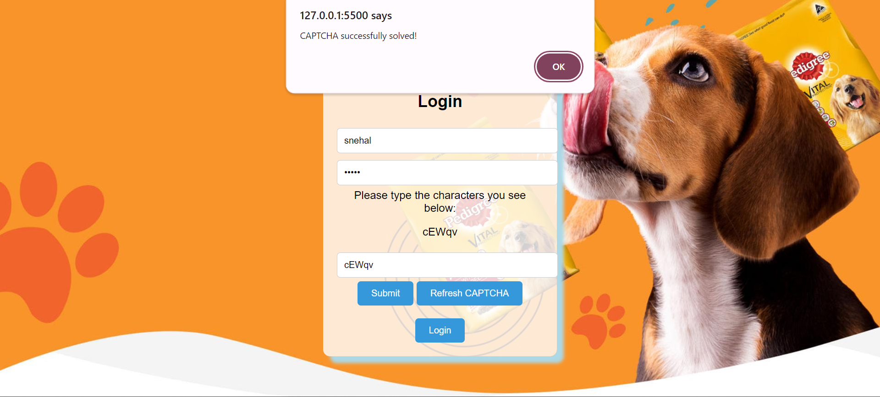

**5.3 Netflix Home page**

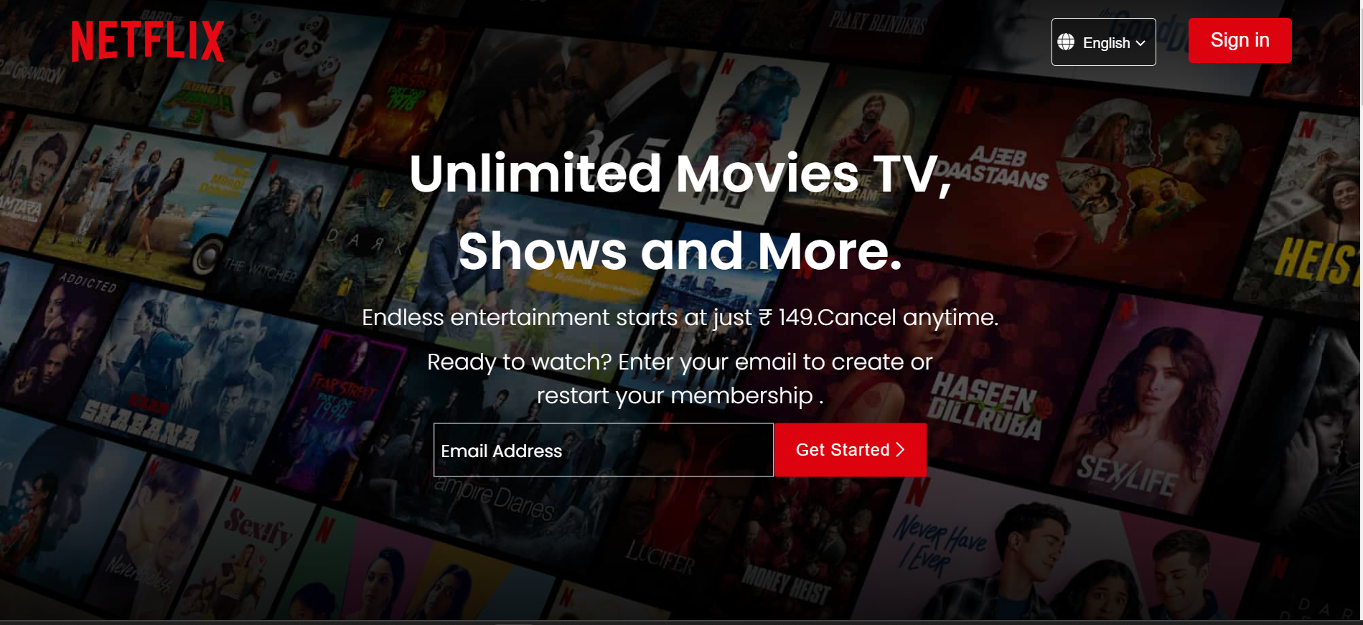

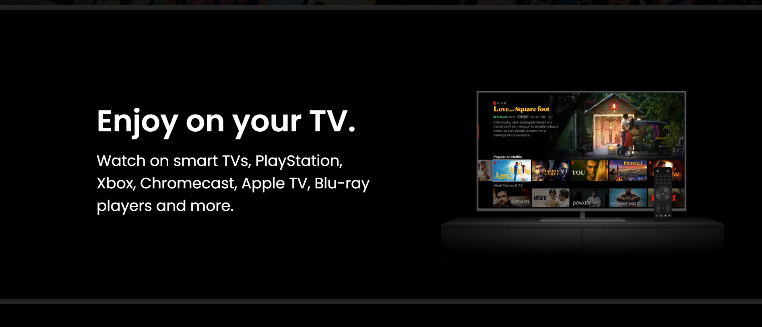

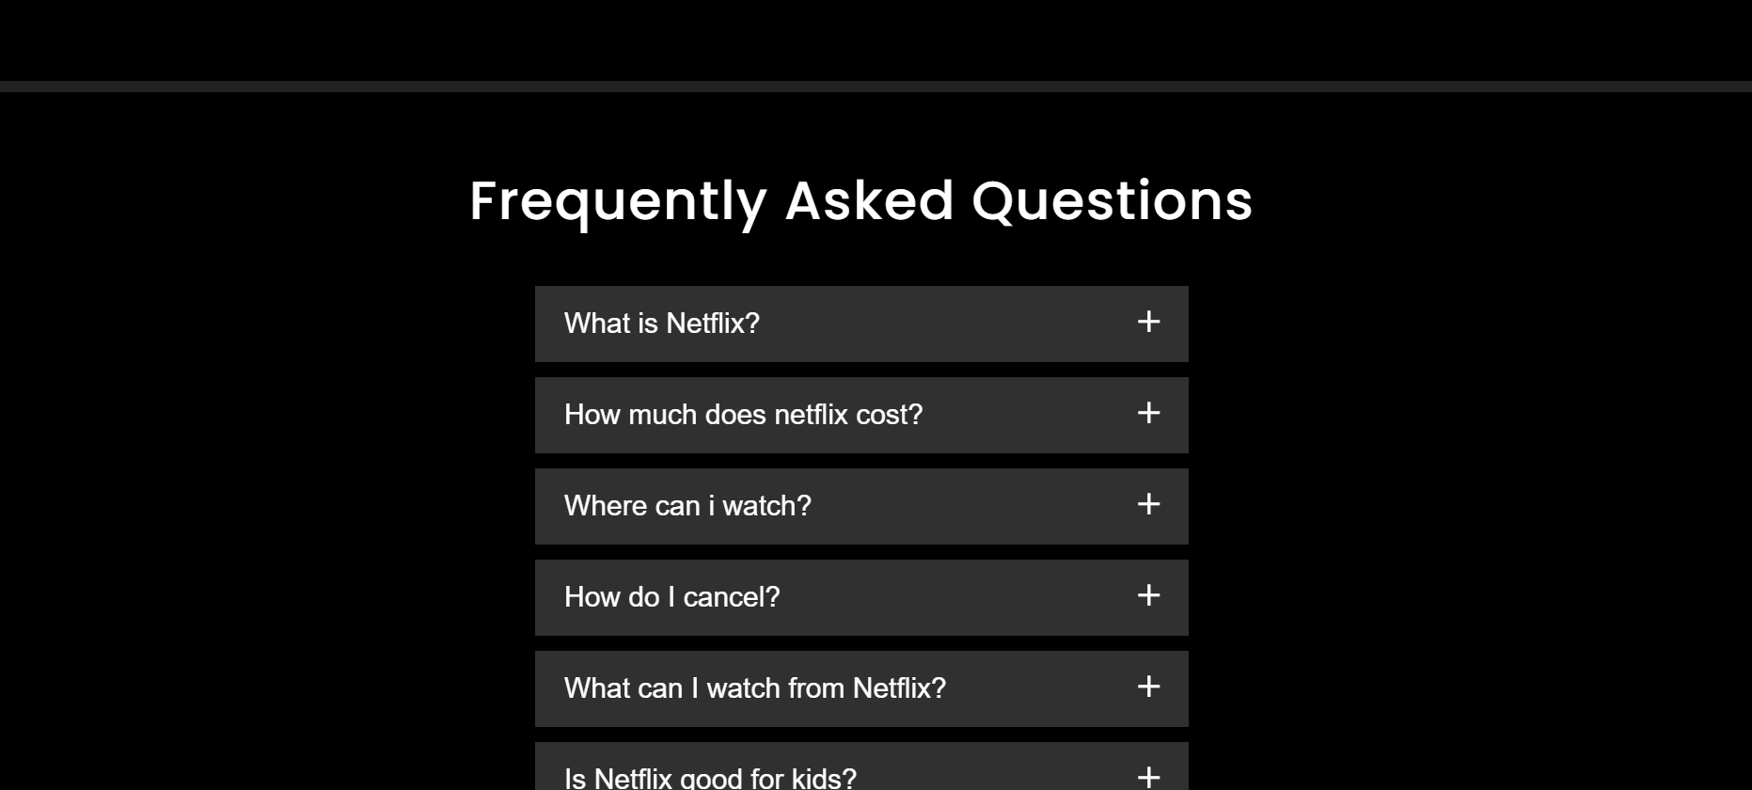

**CONCLUSION**

After completion of this project, I would like to conclude that this project “Kitter website” which has been done to convert a manual system of visiting to computerized system will help a lot to the people. This project has a lot of advantages over the present manual system. It is one of the best projects to manage food Provide rather than the manual system. It will help customers in their requirement to buy animal food item.

REFERENCE/ BIBLIOGRAPHY

* https://tailwindcss.com/
* Website: https://nodejs.org/en and https://www.mongodb.com/docs/
* Software Engineering Roger.S. Pressman
* HTML, CSS, JAVA SCRIPT from http://www.w3schools.com/
* https://react.dev/